Matthew Russell, Joshua Ramayrat

ELEN 123, Mechatronics

Professor Wolfe

Laboratory #2: Sensor calibration and filtering

**Part I: Operating and characterizing the Sharp GP2Y0A21YK**

It was asked to measure the output voltage of a sensor with respect to its distance from a wall. The table with the recorded data is as follows:

|  |  |
| --- | --- |
| Wall (cm) | Voltage Readings (V) |
| 5 | 1.93 |
| 10 | 1.086 |
| 15 | 0.776 |
| 20 | 0.62 |
| 25 | 0.528 |
| 30 | 0.499 |
| 35 | 0.498 |
| 40 | 0.41 |

**Table 1:** voltage readings from the sensor output.

It was also asked to write a program to measure the distance using piecewise linear models with the push of a switch-button. The program is as follows:

*int pinButton = 30;*

*float distance;*

*void setup() {*

*Serial.begin(9600);*

*pinMode(A0, INPUT); //IR sensor output connects to analog input.*

*pinMode(pinButton, INPUT_PULLUP); //pushbutton switch connects to digital input.*

*}*

*void loop() {*

*delay(1000);*

*if (digitalRead(30) == LOW) {*

*float sensorValue = analogRead(A0);*

*float voltage = sensorValue * (5.0 / 1023.0);*

*Serial.println(voltage);*

*if (voltage <= 2 && voltage >= 1) {*

*distance = (-5.9242*voltage) + 16.434;*

*} else if (voltage < 1 && voltage >= 0.75) {*

*distance = (-16.129*voltage) + 27.516;*

*} else if (voltage < 0.75 && voltage >= 0.51) {*

*distance = (-39.447*voltage + 45.299);*

*} else if (voltage < 0.51 && voltage > 0.3) {*

*distance = (-122.24*voltage) + 90.107;*

*}*

*Serial.println(distance);*

*}*

*}*

**Part II: Build your own sensor:**

It was asked to write a program to generate a square wave output using the arduino and observe it through an oscilloscope:

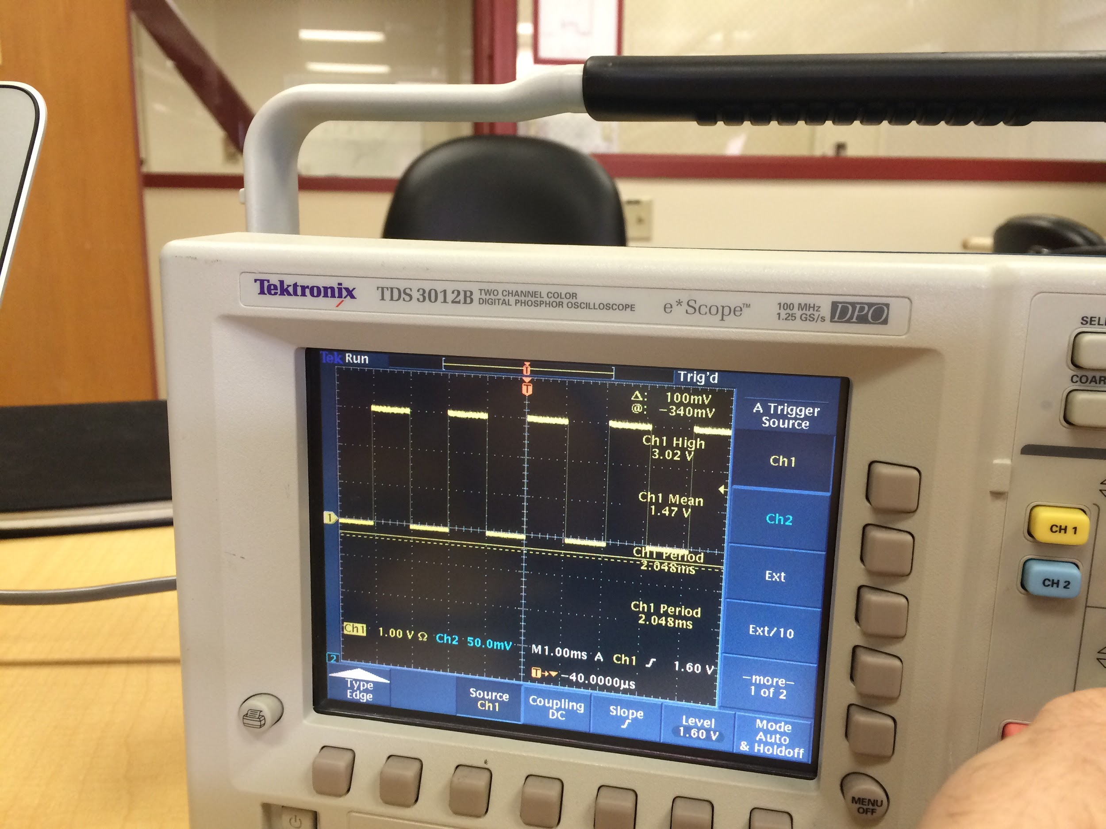

**Figure 1:** Oscilloscope measurements of the square wave out of the arduino.

**Part III: Passive RC Filter**

The cutoff frequency of our filter was computed to be 2.34 kHz according to the following equation and the provided RC value.

$f_{c}= \frac{1}{2πRC}$

Our calculated cutoff frequency compared very favorably with the observed cutoff. We began to see attenuation of the signal around 2.3 kHz. To get a better understanding of what the circuitry was doing we changed the frequency of the square wave and the value of the resistor and watched how the output changed.

Reconfiguring the circuit as a high-pass filter required us to either decrease the cutoff frequency or increase the square wave frequency to get a good reading.